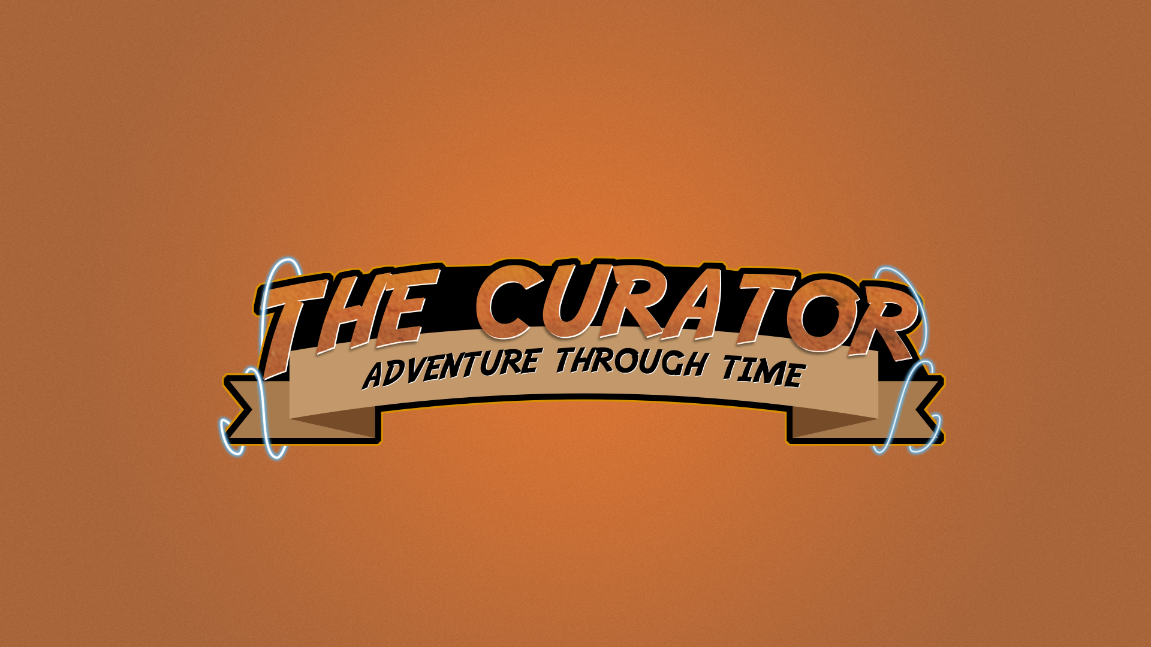

**How is it different ?**

What makes this game stand out is the sheer variety of levels! The open ended nature of the protagonist’s task allows for great scope in storytelling and plot, both centric to each Era and overall throughout the game.

**But is it fun ?**

* When every level can bring an entirely new mini game there really is something for everyone!
* Each Era will hold its own small storyline related to the item that needs curating.

* Simple controls make this game easily approachable, and short but intense levels all help to appeal to the more casual player looking for some easy enjoyment.

**Aesthetics**

Drawn in pixel art and inspired by titles such as Hyper Light Drifter, the original Zelda games, and the original Pokémon games, complemented with chiptune audio for a truly retro appeal.

Time travel allows an unlimited variety of level themes. From Dinosaurs, to Nazis, to alien robots in the future!

**Let’s talk about time. . .**

**A simple pixel art shooter/puzzler set across the ages**

* As ‘The Curator’ you are tasked with retrieving artefacts from throughout time for a museum in the future.
* Each ‘Era’ will vary in style from fast paced shooting sections, to sneaking through mazes. With many short levels, there can be many short styles in one game.



